Hydrography Graphic Organizer

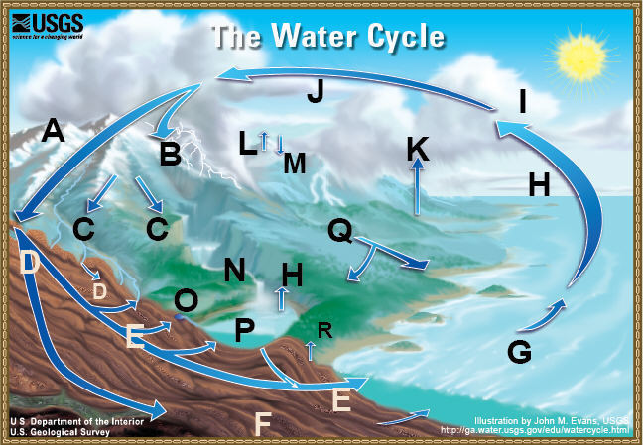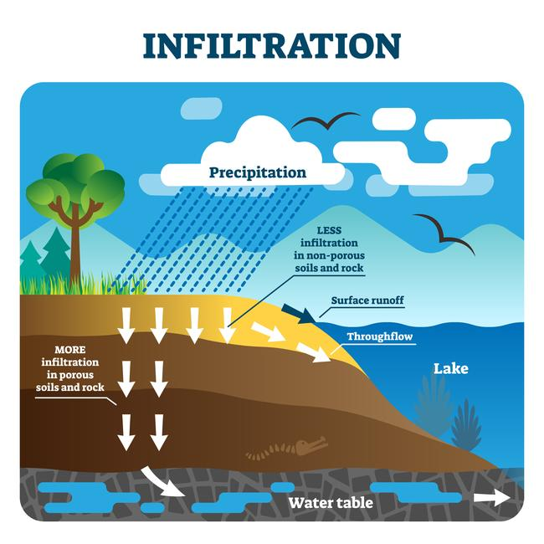

**P**

**S**

**D**

**T**

**F**

**Q**

**D**

**R↑**

|  |  |  |  |
| --- | --- | --- | --- |
| **A** |  | **J** |  |
| **B** |  | **K** |  |
| **C** |  | **N** |  |
| **D** |  | **O** |  |
| **E** |  | **P** |  |
| **F** |  | **Q** |  |
| **G** |  | **R** |  |
| **H** |  | **S** |  |
| **I** |  | **T** |  |

Precipitation

Snow Melt Runoff / Tributaries

River

Surface Runoff

Groundwater Flow

Springs

Condensation

Atmospheric Storage

Infiltration / Seepage

Ocean Storage (Saltwater)

Transpiration

Aquifer / Groundwater Storage

Evaporation

Freshwater Lakes (Storage)

Plant Uptake

Throughflow

Ice, Snow, Glaciers, Permafrost

Percolation

Stages of a Stream Graphic Organizer

|  |  |  |  |
| --- | --- | --- | --- |
|  |  |  |  |
| **Stream Type** |  |  |  |
| **Path** |  |  |  |
| **Valley Formed** |  |  |  |
| **Slope** |  |  |  |
| **Speed / Velocity** |  |  |  |
| **Amount of Erosion** |  |  |  |
| **Flood Plain Width** |  |  |  |
| **Oxbows (Yes/No)** |  |  |  |